BAB 4

# DESKRIPSI PERANCANGAN PERANGKAT LUNAK

**Donasi Online**

**WeCan**

## Dipersiapkan oleh:

Laurentius Yudhistira (1301180303)

Maiza Radhiya (1301180411)

Abigael Mark Stevan (1301180134)

Irfan Ghinafsi (1301180434)

Program Studi Informatika Fakultas Informatika

Jl. Telekomunikasi 1, Dayeuhkolot Bandung

|  |  |  |  |  |
| --- | --- | --- | --- | --- |
|  | **Prodi S1- Informatika Universitas Telkom** | **Nomor Dokumen** | | **Halaman** |
| **DPPL BAB 4** | |  |
| **Revisi** |  |

1. **Perancangan Detil**

### Perancangan Detil Kelas

### TABEL KELAS :

|  |  |  |  |
| --- | --- | --- | --- |
| **ID**  **Kelas** | **Nama Kelas Perancangan** | **Atribute (visibility)** | **Method / Operation** |
| I01 | Halaman Login | Public | loginOnClick() |
| Public | showHalamanLogin() |
| Public | requestHalamanLogin() |
| Public | inputUsername() |
| Public | inputPassword() |
| I02 | Halaman Input Event | Public | inputData() |
| Public | buatOnClick() |
| Public | kembaliOnClick() |
| Public | requestBuatEvent() |
| Public | requestKembali() |
| I03 | Halaman Cari Event | Public | inputSearch() |
| Public | showSearch() |
| Public | requestSearch() |
| Public | searchOnClick() |
| Public | showHalamanInputEvent() |
| Public | requestHalamanInputEvent() |
| Public | showHalamanUtama() |
| I04 | Halaman Input Donasi | Public | submitOnClick() |
| Public | showHalamanInputEvent() |
| Public | requestHalamanInputEvent() |
| Public | inputDataDonasi() |
| I05 | Halaman Riwayat | Public | requestDataRiwayat() |
| Public | tampilDataRiwayat() |
| I06 | Halaman Registrasi | Public | submitOnClick() |
| Public | showHalamanRegist() |
| Public | requestHalamanRegist() |
| Public | inputDataRegist() |
| I07 | Halaman Utama | Public | riwayatOnCariEalick() |
| Public | showHalamanRiwayat() |
| Public | requestHalamanRiwayat() |
| Public | cariEventOnClick() |
| Public | showHalamanCariEvent() |
| Public | requestHalamanCariEvent() |
| Public | showHalamanUtama() |
| I07 | Halaman Welcome | Public | loginOnClick() |
| Public | showHalamanLogin() |
| Public | requestHalamanLogin() |
| Public | showHalamanWelcome() |
| Public | registOnClick() |
| Public | showHalamanRegist() |
| Public | requestHalamanRegist() |
| Public | showHalamanUtama() |
| C01 | Validasi | Public | insertDatatoDatabase() |
| Public | processData() |
| Public | insertBerhasil() |
| Public | insertGagal() |
| Public | showLoginBerhasil() |
| Public | showLoginGagal() |
| Public | prosesBuatEvent() |
| Public | tampilError() |
| Public | validasiData() |
| Public | insertDataDonasi() |
| Public | processData() |
| Public | insertBerhasil() |
| Public | insertGagal() |
| Public | showDonasiBerhasil() |
| Public | showDonasiGagal() |
| Public | DataFound() |
| Public | DataNotFound() |
| Public | showDataBerhasil() |
| Public | ShowDataGagal() |
| Public | insertDataRegist() |
| Public | showRegistBerhasil() |
| Public | showRegistGagal() |
| C02 | Input Event | Public | tampilHalamanInputEvent() |
| Public | tampilHalamanUtama() |
| Public | insertEvent() |
| C03 | Riwayat | Public | ambildataRiwayat() |

### Perancangan Kelas Persistensi (***Basis Data Skema Tabel)

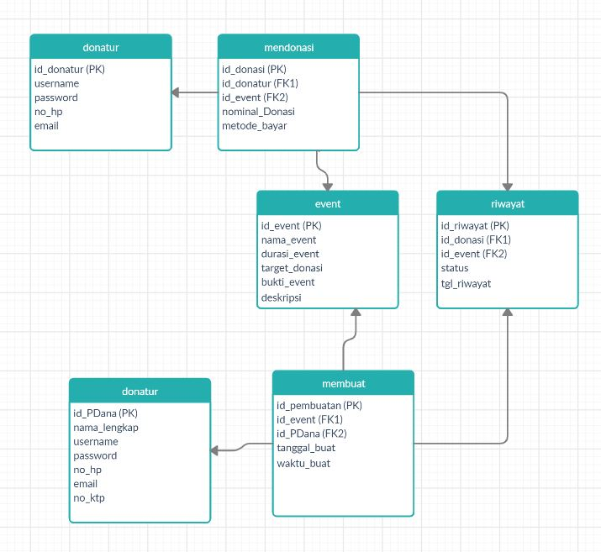

### Perancangan Algoritma

### 4.3.1 Algoritma #1

Contoh:

Nama Kelas : Halaman Input Event

Nama Operasi : inputData()

Algoritma :

String namaEvent = txtNama.getText();

String durasiEvent = txtDurasi.getText();

String targetDonasi = txtTarget.getText();

String buktiEvent = txtBukti.getText();

String deskripsiEvent = txtDeskripsi.getText();

**4.3.2 Algoritma #2**

Contoh :

Nama Kelas : Halaman Input Donasi

Nama Operasi : inputDataDonasi()

Algoritma :

String nomDonasi = “”;

String metode = “”;

If (cbNom1.isSelected()){

nomDonasi = “10.000”;

} else if (cbNom2.isSelected()){

nomDonasi = “20.000”;

} else if (cbNom3.isSelected()){

nomDonasi = “50.000”;

} else if (cbNom4.isSelected()){

NomDonasi = txtNominal.getText();

}

If (cbNom5.isSelected()){

metode = “GoPay”;

} else if (cbNom6.isSelected()){

metode = “LinkAja!”;

} else if (cbNom7.isSelected()){

metode = “OVO”;

} else if (cbNom8.isSelected()){

metode = “Dana”;

### Perancangan Query

|  |  |  |
| --- | --- | --- |
| *No Query* | *Query* | *Keterangan* |
| *Q-001* | *SELECT username, password from table_useDonatur WHERE username like A.getUsername() and password like A.getPassword();* | *Melakukan pengembalian data username dan password dari database untuk digunakan dalam validasi Ketika melakukan login Donatur* |
| *Q-002* | *SELECT username, password from table_PDana WHERE username like A.getUsername() and password like A.getPassword();* | *Melakukan pengembalian data username dan password dari database untuk digunakan dalam validasi Ketika melakukan login Penggalang Dana* |
| *Q-003* | *INSERT INTO registrasi_Donatur*  *VALUES(*  *‘$username’,*  *‘$no_hp’,*  *‘$email’,*  *‘$password’,* | *Meningputkan data registrasi ke table registrasi donatur* |
| *Q-004* | *INSERT INTO registrasi_PGDana*  *VALUES(*  *‘$username’,*  *‘$nama_lengkap’*  *‘$no_hp’,*  *‘$email’,*  *‘$no_ktp’,*  *‘$password’,* | *Meningputkan data registrasi ke table registrasi penggalang dana* |
| *Q-005* | *INSERT INTO event*  *VALUES(*  *‘$nama_event’,*  *‘$durasi_event’,*  *‘$target_donasi’.*  *‘$bukti_event’,*  *‘$deskripsi’* | *Menginput data event baru oleh penggalang dana* |
| *Q-006* | *SELECT nama_event from event WHERE nama_event = <nama_event>* | *Mencari event dari inputan donatur* |
| *Q-007* | *INSERT INTO donasi*  *VALUES(*  *‘$nama_event’,*  *‘$nominal_donasi’,*  *‘$metode_bayar’* | *Input Donasi oleh donatur* |
| *Q-008* | *SELECT * from event* | *Melihat Riwayat event Penggalang Dana* |
| *Q-009* | *SELECT * from donasi* | *Melihat Riwayat transaksi donatur* |